Bandit level 0 to level 1
For login as bandit first use the host and username as
Then you need a initial password as bandit0.
The next command is ls.
The use of ls is to list the files and folders.
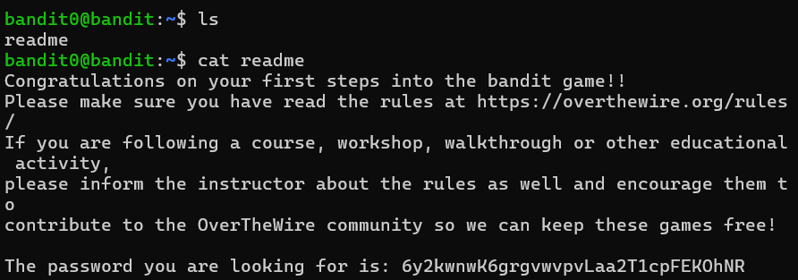
The use of cat is to display the contents of the file.
At finally I got the password for logging in to level1.
The initial level was completed.

